**Property Registration Project**

1. **Network Setup Commands**

**Step 1 - Run the fabric network Set up Script for creating of channels and other artifacts**

./fabricNetwork.sh up

**Step 2 - Install Smart Contract on Peer 0 of both User and Registrar**

1. docker exec -it cli /bin/bash

=============registrar peer================

b) CORE_PEER_LOCALMSPID="registrarMSP"

c)CORE_PEER_MSPCONFIGPATH=/opt/gopath/src/github.com/hyperledger/fabric/peer/crypto/peerOrganizations/registrar.property-registration-network.com/users/Admin@registrar.property-registration-network.com/msp

d) CORE_PEER_ADDRESS=peer0.registrar.property-registration-network.com:7051

e) peer chaincode install -n regnet -v 1.1 -l node -p /opt/gopath/src/github.com/hyperledger/fabric/peer/chaincode/

==============Users peer=====================

f) CORE_PEER_LOCALMSPID="usersMSP"

g)CORE_PEER_MSPCONFIGPATH=/opt/gopath/src/github.com/hyperledger/fabric/peer/crypto/peerOrganizations/users.property-registration-network.com/users/Admin@users.property-registration-network.com/msp

h) CORE_PEER_ADDRESS=peer0.users.property-registration-network.com:9051

i) peer chaincode install -n regnet -v 1.1 -l node -p /opt/gopath/src/github.com/hyperledger/fabric/peer/chaincode/

**Step 3 -Instantiate the Chaincode**

a) docker exec -it cli /bin/bash

=====point to registerar peer0========

b) CORE_PEER_LOCALMSPID="registrarMSP"

c)CORE_PEER_MSPCONFIGPATH=/opt/gopath/src/github.com/hyperledger/fabric/peer/crypto/peerOrganizations/registrar.property-registration-network.com/users/Admin@registrar.property-registration-network.com/msp

d) CORE_PEER_ADDRESS=peer0.registrar.property-registration-network.com:7051

e) peer chaincode instantiate -o orderer.property-registration-network.com:7050 -C registrationchannel -n regnet -l node -v 1.1 -c '{"Args":["org.property-registration-network.com.user:instantiate"]}' -P "OR ('registrarMSP.member','usersMSP.member')"



1. **Smart contract functionality execution/Testing commands**

**// commands for registering new users Seller and Buyer**

1. peer chaincode invoke -o orderer.property-registration-network.com:7050 -C registrationchannel -n regnet -c '{"Args":["org.property-registration-network.com.user:requestNewUser","Seller","connect@rahul.com","124456789","891"]}'



1. peer chaincode invoke -o orderer.property-registration-network.com:7050 -C registrationchannel -n regnet -c '{"Args":["org.property-registration-network.com.user:requestNewUser","Buyer","connect@rahul.com","124456789","124"]}'



**//Approve new users sellers and Buyers**

1. peer chaincode invoke -o orderer.property-registration-network.com:7050 -C registrationchannel -n regnet -c '{"Args":["org.property-registration-network.com.registrar:approveNewUser","Seller","891"]}' 
2. peer chaincode invoke -o orderer.property-registration-network.com:7050 -C registrationchannel -n regnet -c '{"Args":["org.property-registration-network.com.registrar:approveNewUser","Buyer","124"]}'



**// command to view users seller and buyer**

1. peer chaincode invoke -o orderer.property-registration-network.com:7050 -C registrationchannel -n regnet -c '{"Args":["org.property-registration-network.com.registrar:viewUser","Seller","891"]}'



1. peer chaincode invoke -o orderer.property-registration-network.com:7050 -C registrationchannel -n regnet -c '{"Args":["org.property-registration-network.com.registrar:viewUser","Buyer","124"]}'



**// command for Property Registeration with invalid status apart from registered and onSale**

1. peer chaincode invoke -o orderer.property-registration-network.com:7050 -C registrationchannel -n regnet -c '{"Args":["org.property-registration-network.com.user:propertyRegistrationRequest","Seller","891","003","500","registerede"]}'

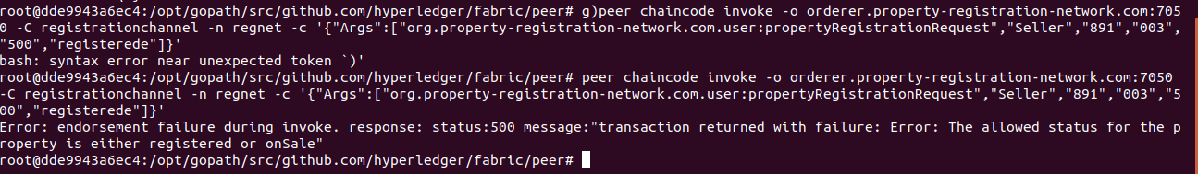

**// command for Property Registration**

1. peer chaincode invoke -o orderer.property-registration-network.com:7050 -C registrationchannel -n regnet -c '{"Args":["org.property-registration-network.com.user:propertyRegistrationRequest","Seller","891","003","500","registered"]}'



**// command for Approve Property**

1. peer chaincode invoke -o orderer.property-registration-network.com:7050 -C registrationchannel -n regnet -c '{"Args":["org.property-registration-network.com.registrar:approvePropertyRegistration","003"]}'



**// command to view Property**

1. peer chaincode invoke -o orderer.property-registration-network.com:7050 -C registrationchannel -n regnet -c '{"Args":["org.property-registration-network.com.registrar:viewProperty","003"]}'

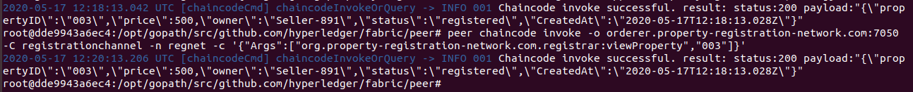

**Note: Current State users Seller and Buyer Registered, Property Registered and in registered state. Property price RS 500 . Users Buyers and sellers having 0 upgradcoins.**

**// command for purchasing property which is still in registered state**

1. peer chaincode invoke -o orderer.property-registration-network.com:7050 -C registrationchannel -n regnet -c '{"Args":["org.property-registration-network.com.user:purchaseProperty","003","Buyer","124"]}'



// **command for updating property to onSale state**

1. peer chaincode invoke -o orderer.property-registration-network.com:7050 -C registrationchannel -n regnet -c '{"Args":["org.property-registration-network.com.registrar:updateProperty","003","Seller","891","onSale"]}'



**// command to purchase the property onSale without having enough account balance**

1. peer chaincode invoke -o orderer.property-registration-network.com:7050 -C registrationchannel -n regnet -c '{"Args":["org.property-registration-network.com.user:purchaseProperty","003","Buyer","124"]}'



**// command to recharge the account to purchase the property without a valid transaction id like upg1000,upg500,upg100**

1. peer chaincode invoke -o orderer.property-registration-network.com:7050 -C registrationchannel -n regnet -c '{"Args":["org.property-registration-network.com.user:rechargeAccount","Buyer","124","upg10000"]}'



**// command to recharge the account to purchase the property**

1. peer chaincode invoke -o orderer.property-registration-network.com:7050 -C registrationchannel -n regnet -c '{"Args":["org.property-registration-network.com.user:rechargeAccount","Buyer","124","upg1000"]}'



// Command to purchase the property which is on sale having enough account balance. The money of property price will be added to sellers account and debited from buyers and ownership of property will change to buyer and state of property will change to registered.

P) peer chaincode invoke -o orderer.property-registration-network.com:7050 -C registrationchannel -n regnet -c '{"Args":["org.property-registration-network.com.user:purchaseProperty","003","Buyer","124"]}'



Note: I have also attached a text file Execution commands.txt which contains all the commands to help if any formatting issues happen between copy paste.